### **Tugas**

1. Create Simple API Testing Automation and workflow for GitHub Actions.

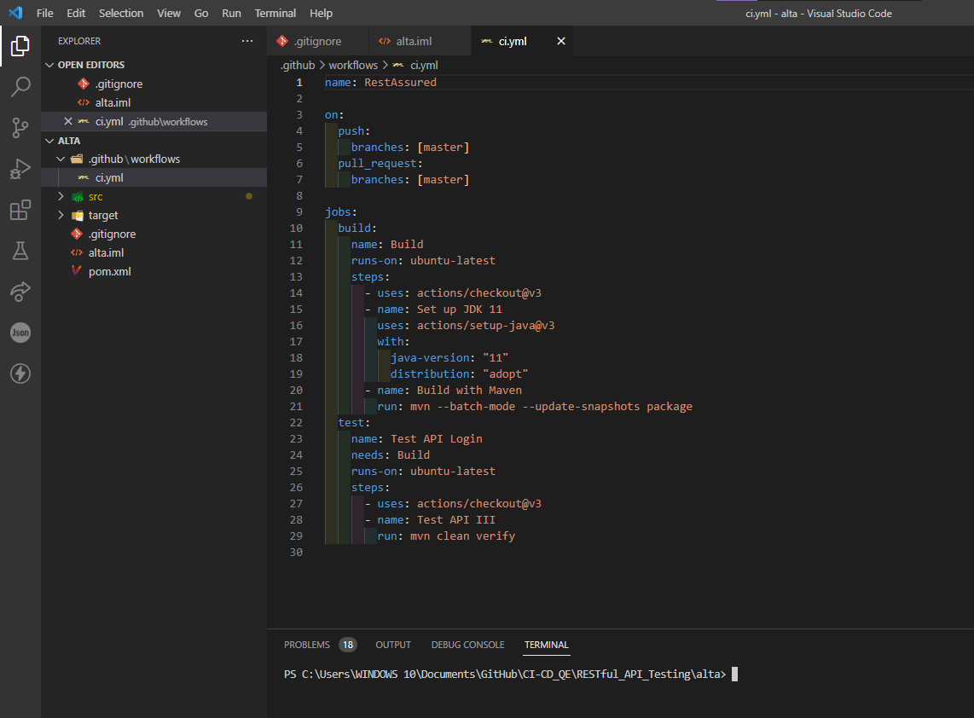

1. Create New Repository on GitHub.

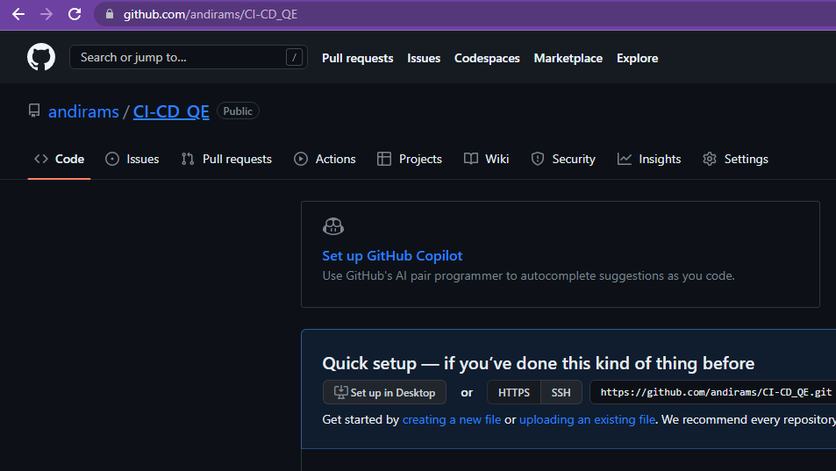

1. Push to Repository.

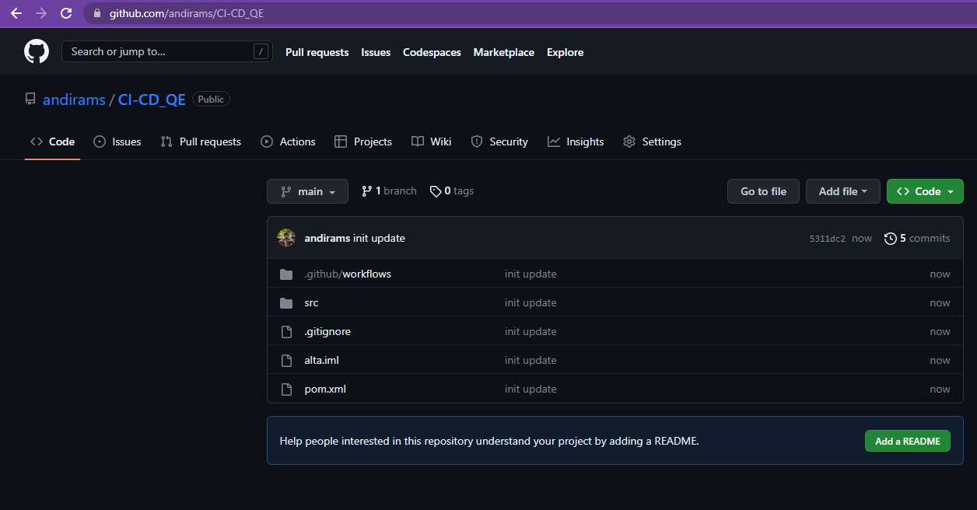

1. Check the Results of CI from GitHub Actions.

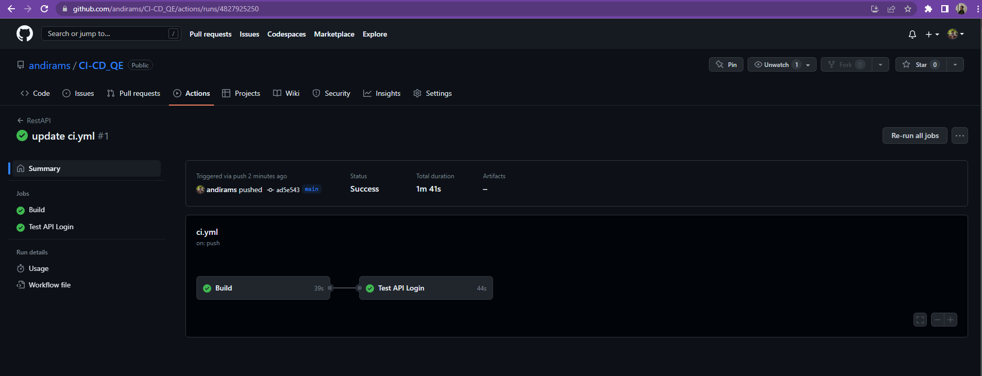

1. Create New branch (example: test/api-login).

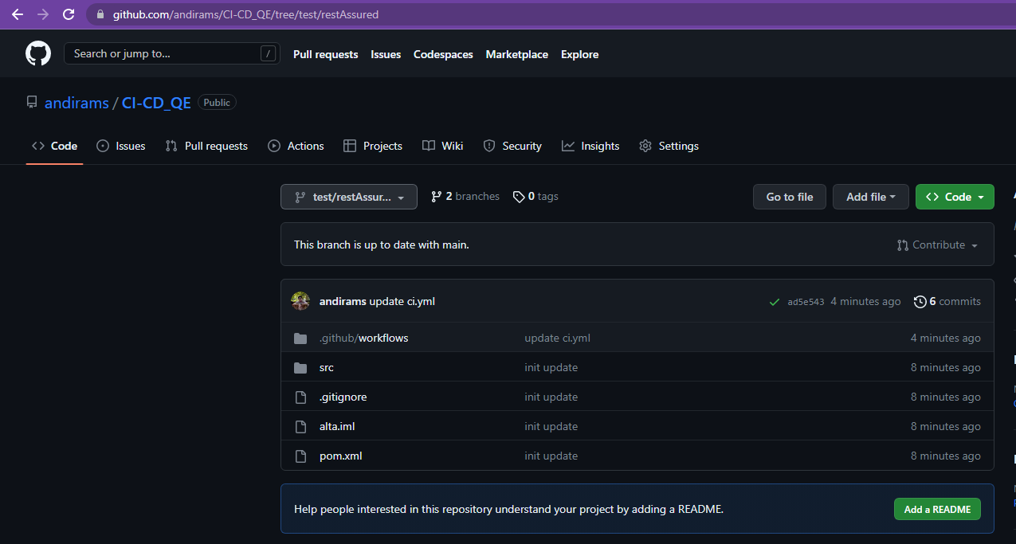

1. Create 1 Test Case for API Testing on New Branch.

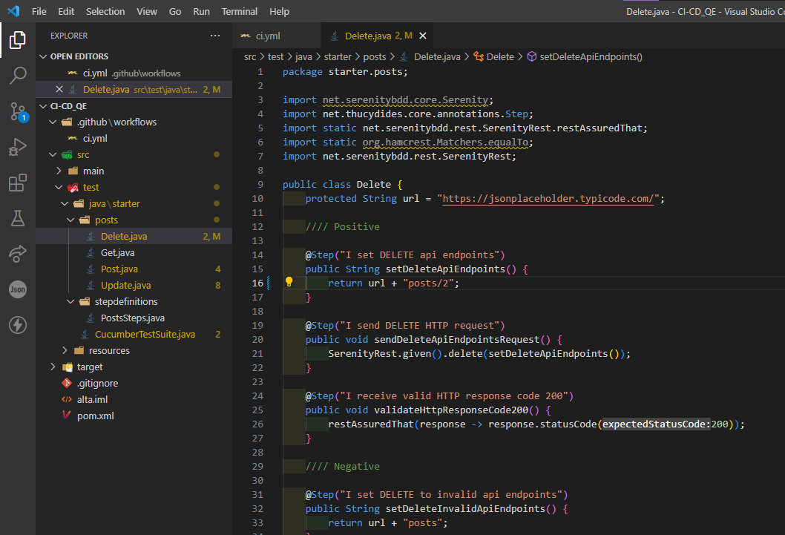

1. Push to New Branch.

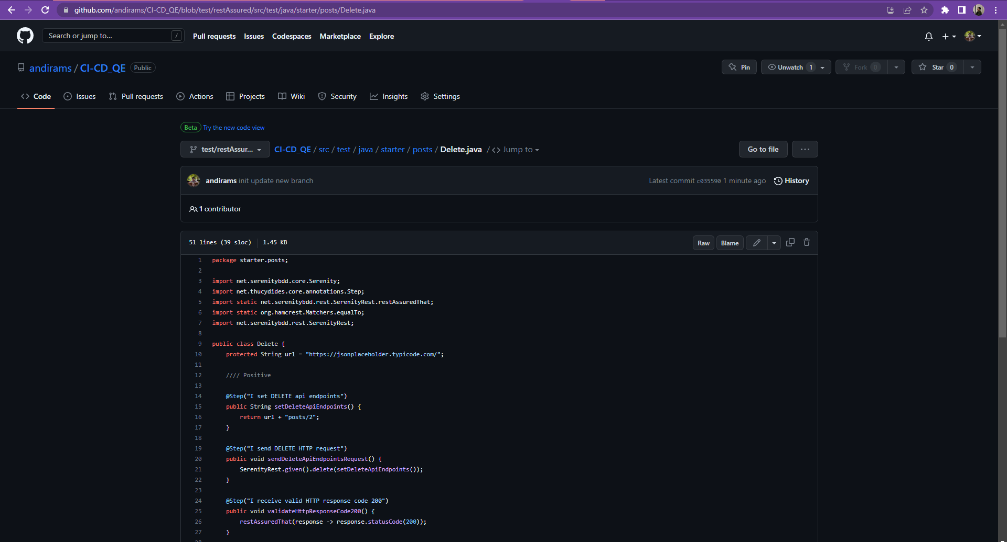

1. Create Merge Request (Check whether CI is running or not).

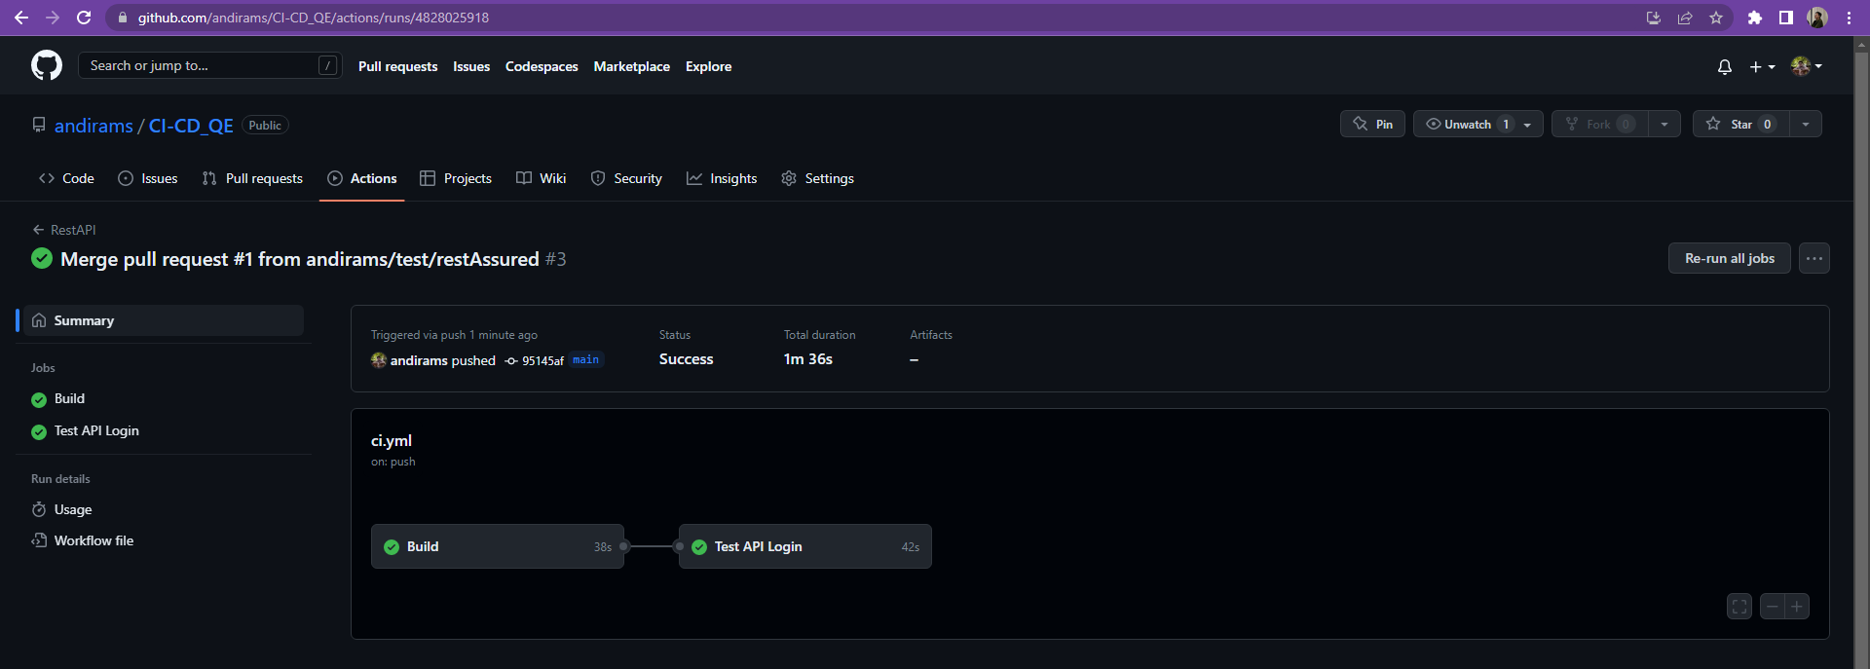

1. Merge to master (Check whether CI is running or not).

